Grievance form
Please complete, print, sign and return to Paula Lukins/Lauren Wilkinson
Name | 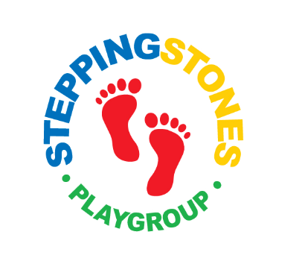
Job Title

Type of grievance (tick box)
General | Health & Safety | Terms & Conditions | Discrimination (sex/race/disability) | Harassment

Details of your Grievance

What would you like to see happen

Signature: Date:

Apparent Misconduct – Employee Suspended if Appropriate

Conduct investigation

Investigation indicates further No formal action required,
action deemed necessary informal action such as additional training, words of advice etc may be offered

Employee issued written
invitation to disciplinary
hearing

Disciplinary hearing held and
mitigating factors/facts
considered

Meeting will be adjourned and
decision made

Outcome decision issued eg
no action, warning or dismissal
and right of appeal

Appeal No appeal

Updated and implemented Autumn Term 2023– reviewed regularly and the procedure monitored and evaluated

